**CS 5600 Group Assignment: Database Description**

**Database Description**

The E-learning, Assignment, Testing and Grading System application maintains data of each registered user. The following information is captured from each user to create an account : Name, Email, Password, phone number, Subjects where the list of Subjects are collected from the separate document referred as Subjects. We maintain each selected Subject and its Content provided by the instructor for the self-learning of the student in the document referred as E-Learning.

We maintain the uploaded assignments by the Instructors for each Subject in the document referred as Assignments where the file_id of the uploaded file relative to the subject (For example Java, Html, Sql ) is stored. The completed assignment by the student for each Subject is maintained in the document named AssignmentSubmisssion where the file_id of the uploaded file relative to the subject (For example Java, Html, Sql ) is stored with the help of the user_id.

The actual uploaded File Name, Content Type, Chunk Size, Length, and the uploaded Date of the file is stored in the document fs.Files. The assignment Data(Content) in the uploaded file is maintained in the document fs.chunks with the help of the file_id where if the content is large, it splits the content into multiple json objects with the sequence key n in the document.

We maintain the qsts(Questions) and answers for each Subject posted by the instructor in the document named Questions which will be helpful for students to attempt the exam and get the instant result by auto validating with the provided answers in the document.

We store the details of each student with the user_id, the subject name (For example Java, Html, Sql ) on which the exam is attempted as the key and the marks as the value of the subject name in the document named Result which is used to retrieve the students report.

**NoSQL Database Design**

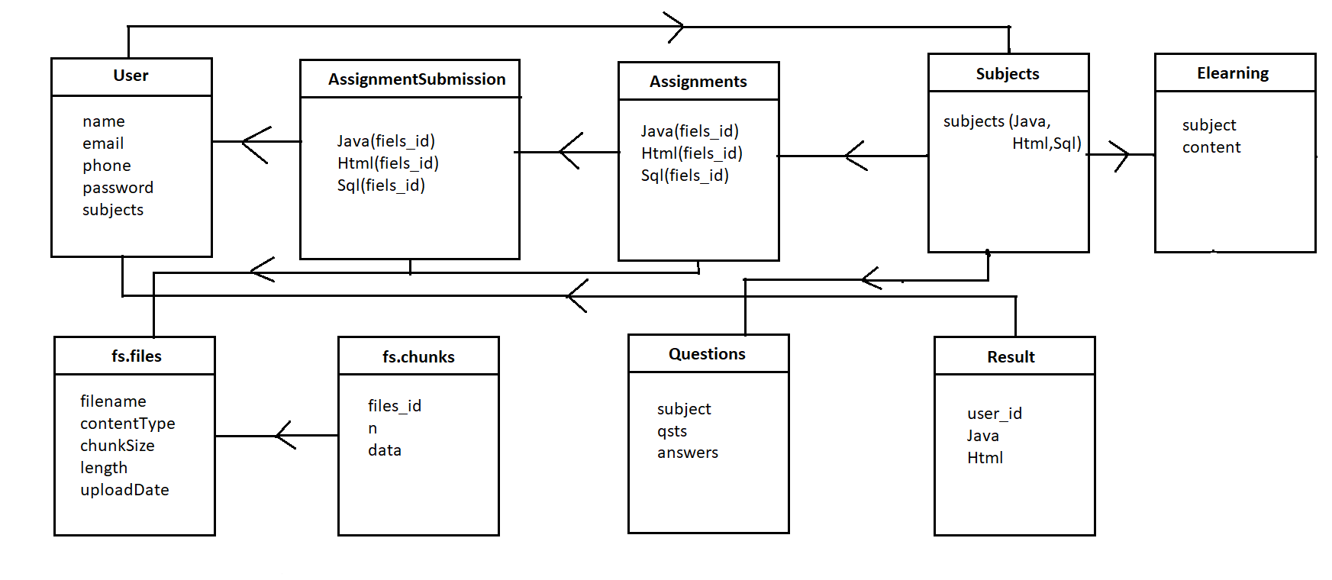

**Database Collections**

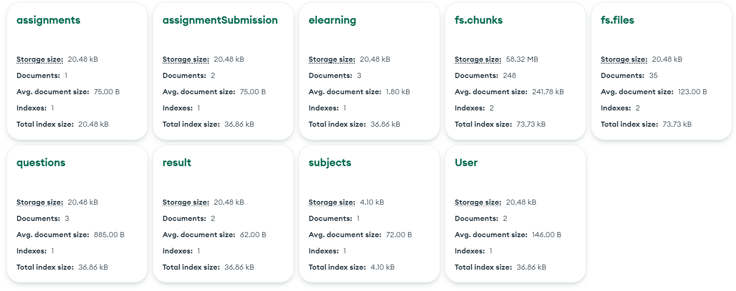

**Sample data**

**User :**

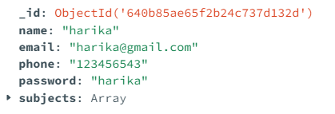

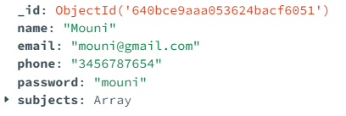

**Assignments :**

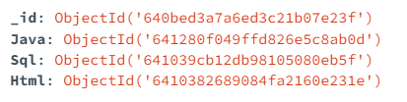

**AssignmentSubmission :**

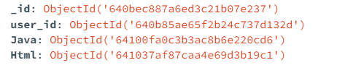

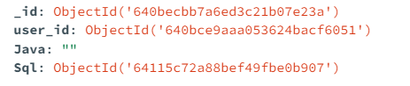

**Elearning :**





**Fs.files :**

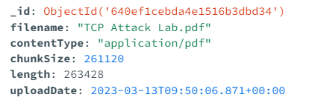

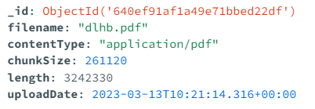

**Fs.chunks**





**Questions :**

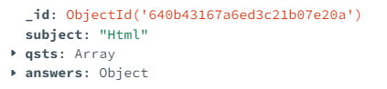

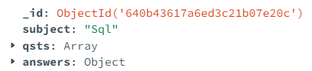

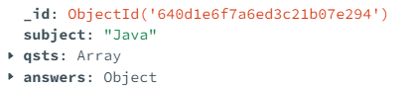

**Result :**

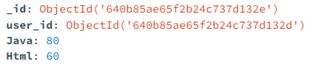

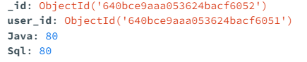

**Subjects :**

